To find the frequency of each word in a given input text:

Aim:
To write a C program to find the frequency of each word in a given input text
Algorithm:
- Start the program.
- Read the input text from the user.
- Extract each word from the input text.
- Compare each word with the previously stored words.
- If the word already exists, increment its frequency; otherwise, store the word and initialize its frequency to 1.
- Display each word along with its frequency.
- Stop the program.

Pseudocode:
BEGIN
DECLARE text, words, count
READ text
SET n = 0

FOR each word in text DO
SET found = FALSE

FOR i = 0 TO n - 1 DO
IF word equals words[i] THEN
INCREMENT count[i]
SET found = TRUE
BREAK
END IF
END FOR

IF found = FALSE THEN
STORE word in words[n]
SET count[n] = 1
INCREMENT n
END IF
END FOR

FOR i = 0 TO n - 1 DO
DISPLAY words[i], count[i]
END FOR
END

Code:

#include <stdio.h>
#include <string.h>
#include <ctype.h>

int main()
{
char text[1000];
char words[100][50];
int count[100] = {0};
int n = 0, i, j;
char word[50];
int k = 0, found;

printf("Enter the input text:\n");
fgets(text, sizeof(text), stdin);

for (i = 0; ; i++)
{
if (isalnum((unsigned char)text[i]) || text[i] == '_')
{
if (k < 49)
word[k++] = text[i];
}
else
{
if (k > 0)
{
word[k] = '\0';
found = 0;

for (j = 0; j < n; j++)
{
if (strcmp(words[j], word) == 0)
{
count[j]++;
found = 1;
break;
}
}

if (!found && n < 100)
{
strcpy(words[n], word);
count[n] = 1;
n++;
}

k = 0;
}

if (text[i] == '\0')
break;
}
}

printf("\nWord Frequency:\n");

for (i = 0; i < n; i++)
printf("%s : %d\n", words[i], count[i]);

return 0;
}

Ouput:

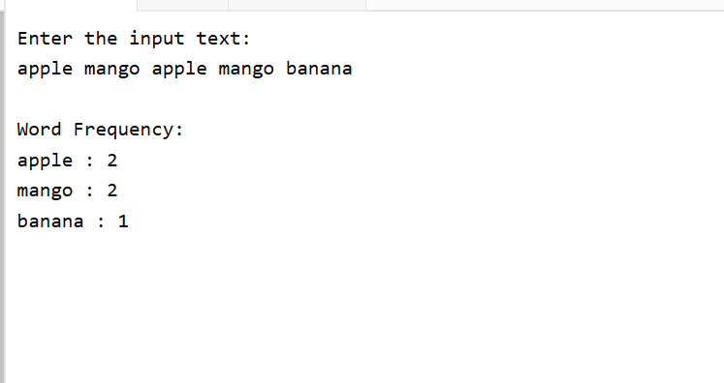

Result:
Thus, the C program was executed successfully to find and display the frequency of each word in the given input text.

